iSphere Ant Plug-In
The iSphere Ant Plug-In provides Ant tasks that are required to build the iSphere plug-ins.

Installation Instructions
Please follow these steps to install the ISphere Ant Plug-In:
- Goto Help -> Install New Software…
- Press the [Add] button to add a new update site:
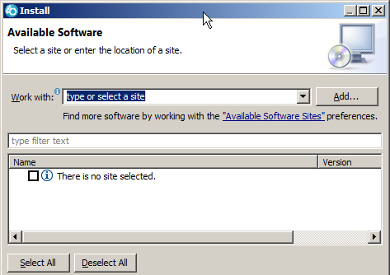
- Specifiy a name and the path to the update site zip file:
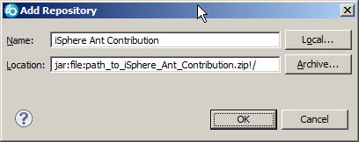
- Press the [OK] button.
- Select the iSphere update site from the drop down box and install the plug-in:
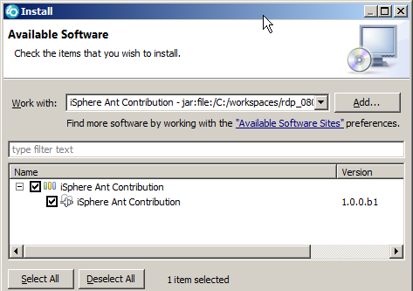

Configuration
There is no further configuration required, as long as you run your Ant script in the JRE of the Eclipse workspace.
But sometimes there are good reasons to use a separate JRE. For that case you need to add a <taskdef> type entry to your Ant script like this:
<!-- Include iSphere Ant Contrib tasks -->
<property name="isphere.ant.contrib.path"
location="your_jacob_lib_path" />
<taskdef resource="biz/isphere/antcontrib/antlib.xml" >
<classpath>
<pathelement location="${isphere.ant.contrib.path}/iSphere-ant-standalone.jar" />
<pathelement location="${isphere.ant.contrib.path}/jacob.jar" />
</classpath>
</taskdef>
In order to make that work, you need to unpack the following files to the directory specified at your_jacob_lib_path:
jacob-1.17-x64.dll
jacob-1.17-x86.dll
jacob.jar
These files are shipped with the iSphere-ant-standalone.jar and these files are unpacked to your “plugins” directory when you install the iSphere Ant Plug-In. Hence you certainly can set your_jacob_lib_path to for example:
c:\Programme_x86\IBM\SDP_091\plugins\biz.isphere.antcontrib_1.0.0.b4\lib\
A complete working example for the location above looks like this:
<!-- Include iSphere Ant Contrib tasks -->
<property name="isphere.ant.contrib.path"
location="c:/Programme_x86/IBM/SDP_091/plugins/biz.isphere.antcontrib_1.0.0.b4/lib/" />
<taskdef resource="biz/isphere/antcontrib/antlib.xml">
<classpath>
<pathelement location="${isphere.ant.contrib.path}/iSphere-ant-standalone.jar" />
<pathelement location="${isphere.ant.contrib.path}/jacob.jar" />
</classpath>
</taskdef>
<target name="build" description="Test It!">
<property name="doc.path" location="${basedir}" />
<winword file="${doc.path}\Test.doc" visible="true"
jacobdllpath="${isphere.ant.contrib.path}" >
<saveAs toFile="${doc.path}\Test_Out.pdf" saveFormat="pdf" />
<saveAs toFile="${doc.path}\Test_Out.doc" saveFormat="doc" />
</winword>
</target>

Debugging
A debug log to standard out can be enabled with environment variable biz.isphere.antcontrib.debug.

Values:
Value | Description
true | Enables the debug log.
False | Disables the debug log. (default setting)

Example:
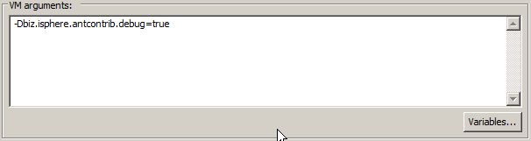

Ant Tasks

winword
The winword task is used to manipulate Microsoft Word documents.

Parameters:
Attribute | Description | Required
file | The file to load. | Yes
visible | Specifies whether or not the MS Word application is started with a window (visible) or without a visible window. | No – default is “true”
jacobDllPath | Specifies the directory that contains the JACOB DLL files: jacob-*-x64.dll and jacob-*-x86.dll  This attribute is not required when the Ant script uses the JRE of the workspace. | No

Nested elements:

saveAs
Attribute | Description | Required
toFile | Name of the renamed file or location where you save the file. | No – default is the original file name
saveFormat | Format you want to save the file. | No – default is the original file format.

Example:
<winword file="Test.doc" visible="true" >
<saveAs saveFormat="pdf" />
</winword>
Converts “Test.doc” to PDF and saves it to “Test.pdf”.
<winword file="Test.doc" visible="true" >
<saveAs toFile="Test_out.pdf" />
</winword>
Converts “Test.doc” to PDF and saves it to “Test_out.pdf”.
<winword file="Test.doc" visible="true" >
<saveAs toFile="Test_out.doc" saveFormat="pdf" />
</winword>
Converts “Test.doc” to PDF and saves it to “Test_out.doc.pdf”.

External Libraries
jacob.jar JACOB – Java COM Bridge
See: https://sourceforge.net/projects/jacob-project/

